**SOFWARE TESTING ASSIGNMENT**

Module – 1 (Fundamental)

* **What is SDLC**

A software development Life cycle (SDLC) is essentially a series of steps, or phases, that provide a modal a modal for the development and life cycle management of an application or piece of software.

Example:

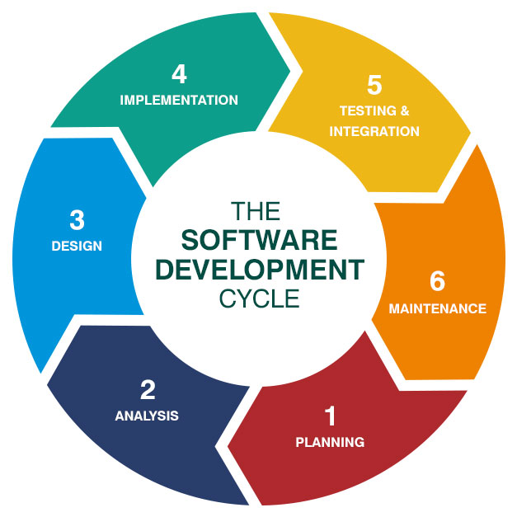

* **What is software testing?**
* Software testing is a process used to identify the correctness, completeness, and quality of developed computer software.

when asked, people of ten think that testing only consists of running tests.

* The benefit of testing includes preventing bugs, reducing development costs and improving performance.
* Software testing standards is ANSI / IEEE - 1059
* **What is Agile methodology?**

The agile methodology is a way to manage a project by breaking it up into several phases.it involves constant collaboration with stakeholders and continuous improvement at every stage.

The combination of iterative and incremental modal.to focus on a process adaptably and customer satisfaction by rapid delivery of working software product.

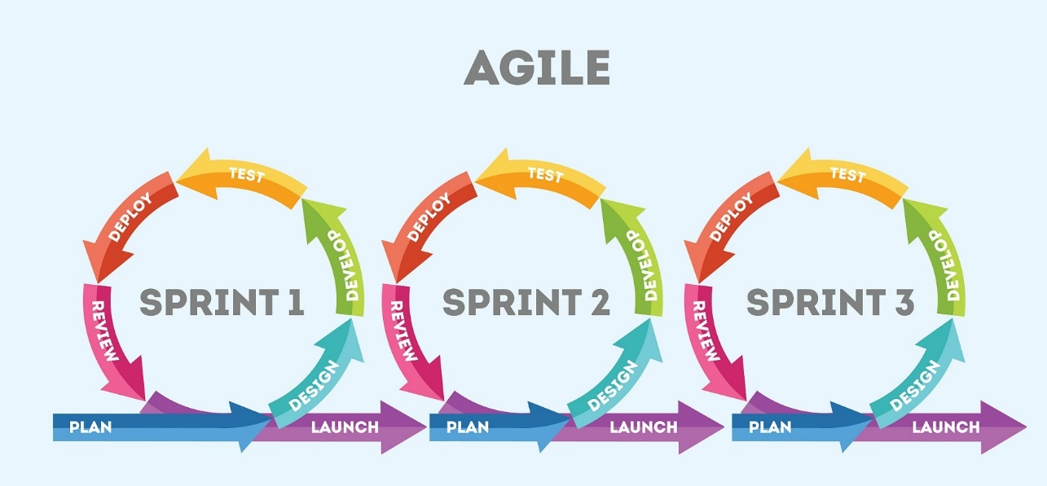

**Advantages**

* Suitable for big project.
* Product is developed fast and frequently delivered (weeks rather then months.)
* Flexibility to adapting.

**Disadvantages**

* it is not useful for small projects.
* Depends heaving on customer interaction.
* Cost of agile development methodology is costly.
* **What is SRS**

A software requirements specification (SRS) is a documents that describe what the software will do and how it will be expected to perform.

* The institute of electrical and electronics engineers publishes several dozen software engineering standards, including IEEE Std 830-1998.
* **What is oops**

Object – oriented programing (oop) is a computer programing modal that organizes software design around date, or objects, rather than functions and logic.

* **Write basis concepts of oops**

There are some basic concepts that act as the building oops.

* Classes & objects
* Abstraction
* Encapsulation
* Inheritance
* Polymorphism
* **What is objects**

The objects concepts is the knowledge that objects are permanent, independent entities that exist in space and time even when one cannot perceive or act on them.

For examples : your car, house, computer etc. all are objects.

* **What is class**

The class defines the blueprint of objects. they define the properties and functionalities of the objects.

For example : Leptop is a class and your leptop is an instance of it.

* **What is encapsulation**

Encapsulation is the technique used to implement abstraction in object – oriented programing.

Encapsulation is used for access restriction to class members and methods.

* **What is inheritance**

Inheritance is the object – oriented programming concept where an object is based on another object. inheritance is the mechanism of code reuse. The object that is getting inherited is called the superclass and the object that inherits the superclass is called a subclass.

* **What is polymorphism**

Polymorphism is the concept where an object behaves differently in different situations.

There are two types of polymorphism :

* Compile time polymorphism
* Runtime polymorphism
* **Usecase online book shopping**

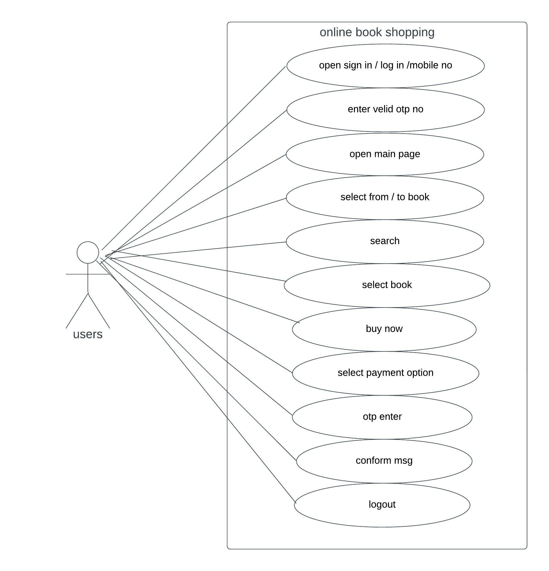

* **Usecase online bill payment system (paytm)**

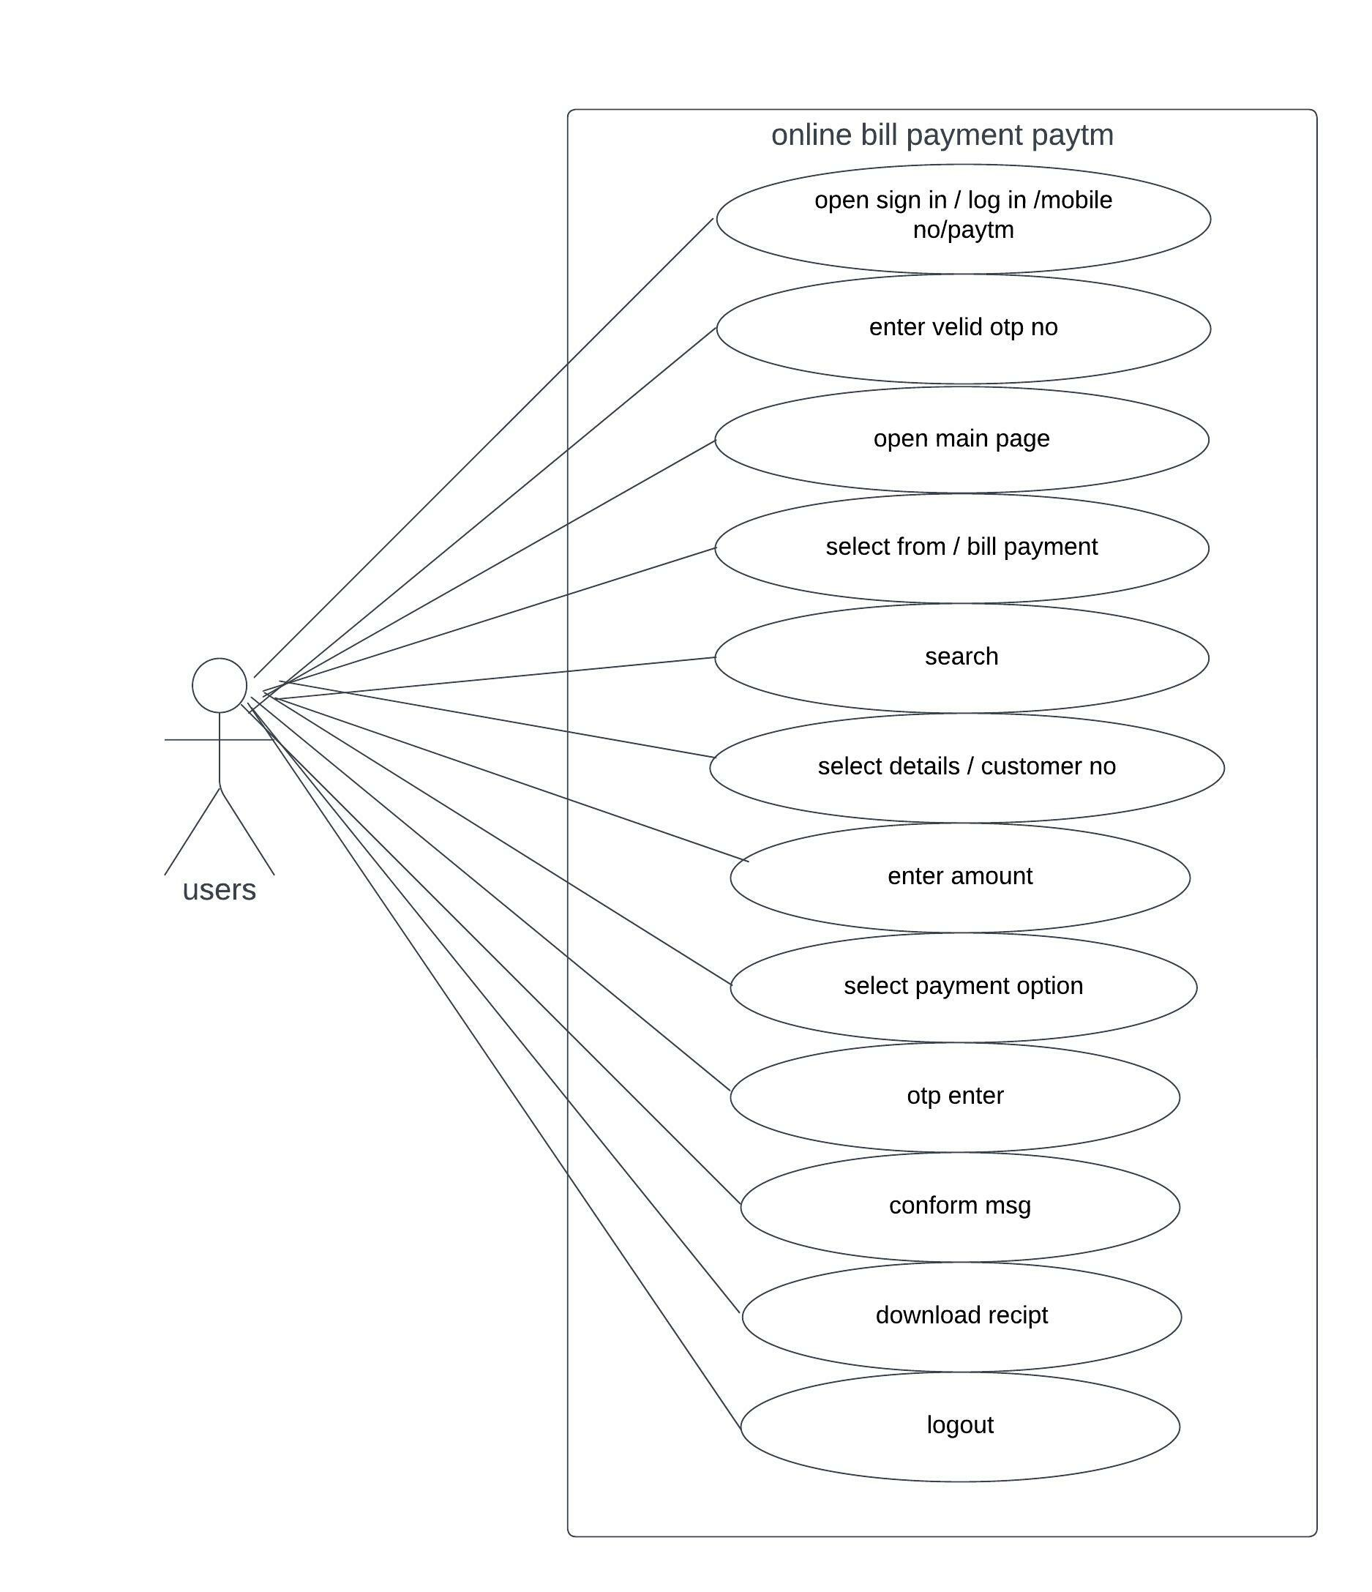

* **Write SDLC phases with basic introduction**

Developments process there are 6 phases in SDLC modal.

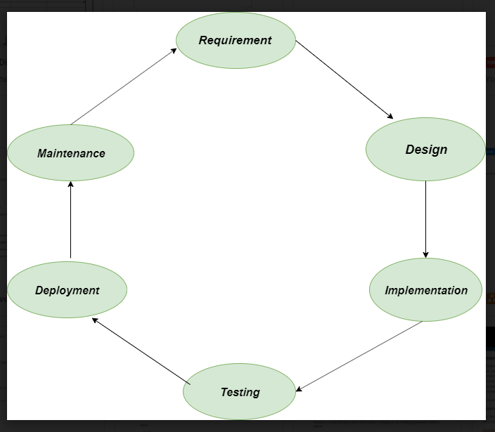

1. **Requirements**

In this phase, all the requirements are collected from the customer/client. They are provided in a document called businessmen requirement specification (BRS) and system requirement specification (SRS).

* All the details are discussed with the customer / client in details.

1. **Design**

It has two steps:

**High – level design** (HLD) : it given the architecture of software products.

**Low – level design** (LLD) : it describes how each and every feature in the product should work and every component.

1. **Implementation**

This is the longest phase

* Front – end : development of coding is done
* Middleware : they connect both the front end and back end.
* Back – end : a database is created.

1. **Testing**

Testing is carried out to verify the entire system.the aim of the tester is to find out the gaps and defects within the system and also to check whether the system is running according to the requirement of the customer / client.

1. **Deployment**

After successful testing,the product is delivered / deployed to the client,the even clients are trained on how to use the product.

1. **Maintenance**

Once the product has been delivered to the client a task of maintenance starts as when the client will come up with an error the issue should be fixed from time to time.

* **Explain phases of the waterfall modal**

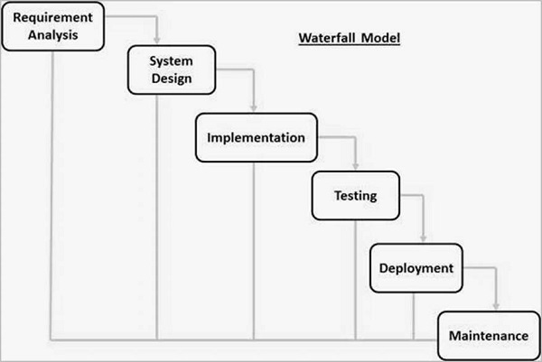

1. **Requirements analysis**

All possible requirements of the system to be developed are captured in this phase and documented in a requirement specification document.

1. **System design**

the requirement specifications from first phase are studied in this phase and the system design is prepared.

1. **Implementation**

With inputs from the system design,the system is first developed in small programs called units,which are integrated in the next phase.each unit is developed and tested for its functionality,which is referred to as unit testing.

1. **Testing**

All the units developed in the implementation phase are integrated into a system after testing of each unit.

1. **Deployment**

Once the functional and non-functional testing is done the product is deployed in the customer environment or released into the market.

1. **Maintenance**

There are some issues which come up in the client environment.to fix those issues, patches are released.

* **Phases of spiral modal**

The below diagram shows the different phases of the spiral modal

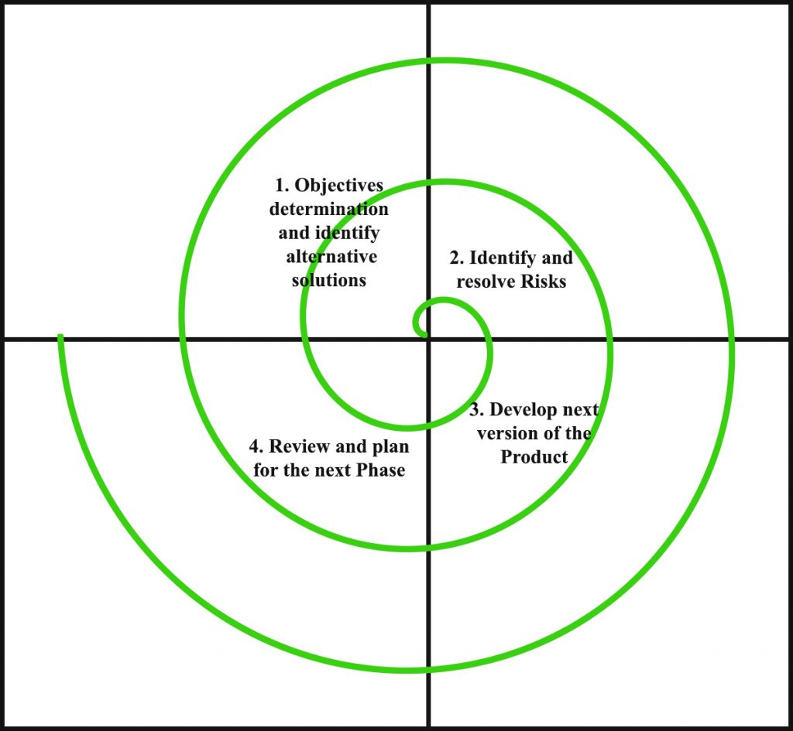

It has four stages or phases.

1. **Objectives determination and identify alternative solutions**

Requirements are gathered from the customers and the objectives are identified, elaborated, and analyzed at the start of every phase.

1. **Identify and resolve risks**

During the second quadrant, all the possible solutions are evaluated to select the best possible solution. then the risks associated with that solution are identified and the risks are resolved using the best possible strategy.

1. **Develop next version of the product**

During the third quadrant, the identified features are developed and verified through testing.at the end of the third quadrant, the next version of the software is available.

1. **Review and plan for the next phase**

In the fourth quadrant, the customers evaluate the so far developer version of the software.in the end, planning for the next phase is started.

* **Write agile manifesto principles**

1. Satisfy customers through early & continuous delivery
2. Welcome changing requirements even late in the project
3. Deliver value frequently
4. Break the silos of your project
5. Build project around motivated individuals
6. The most effective way of communication is face-to-face.
7. Working software is the primary measure of progress
8. Maintain a sustainable working pace
9. Continuous excellence enhances agility
10. Simplicity is essential
11. Self- organizing teams generate most value
12. Regularly reflect and adjust your way of work to boost effectiveness.

* **Explain working methodology of agile modal and also write pros and cons.**

The agile methodology is a way to manage a project by breaking it up into several phases.

|  |  |
| --- | --- |
| Pros | Cons |
| More flexible | hard to predict |
| Product get to market faster | final product is not released first |
| better communication | Documentation gets left behind |

* **Usecase on online Mobile shopping product COD.**

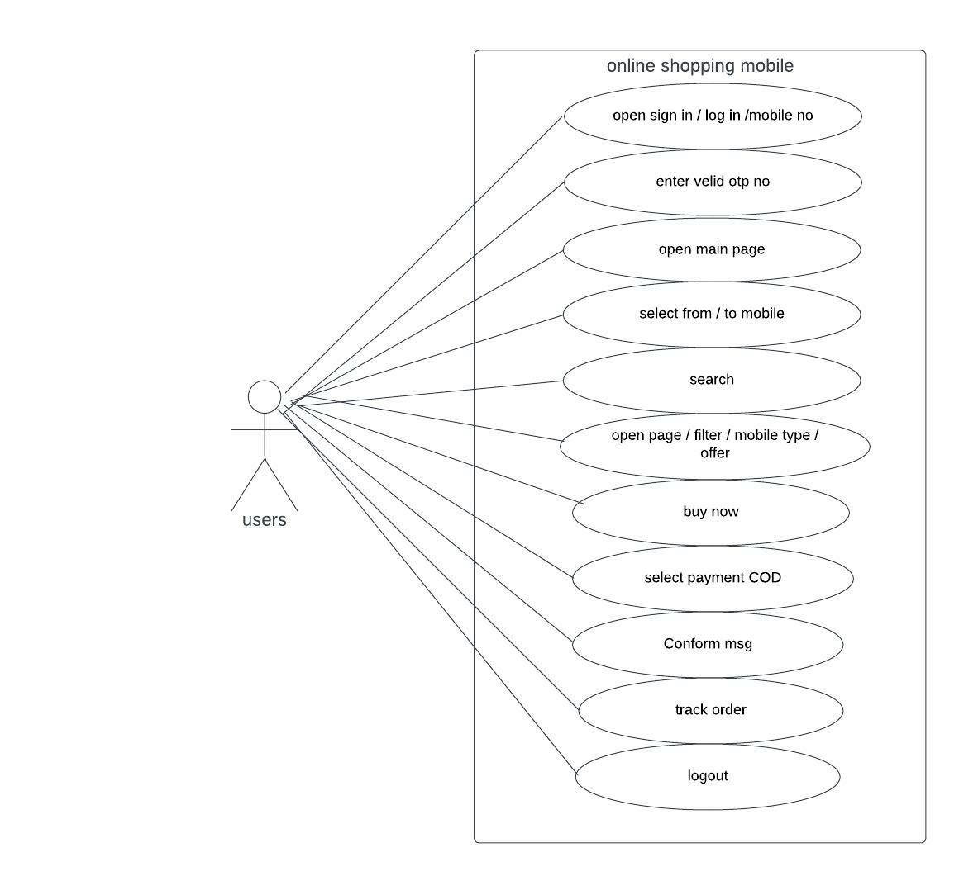

* **Usecase on online Tv shopping product payment gateway.**

